Vectors and Linear motion Total marks

Name: ___SOLUTIONS________ Date: _______________

*For full marks, clearly show your working.*

Question 1 ( 2 marks)

A super-bouncy ball hits a wall with a velocity of 7.0 m s–1 east andrebounds with a velocity of 6.0 m s–1 west. Determinethe change in velocity of the ball.

*Defining east as positive:*

*Δ*v *=* v *–* u

*= –6 – 7*

*= –13*

*Hence Δ*v *= 13 m s–1 west (1 mark magnitude, 1 mark direction)*

Question 2 (1 mark)

Which of the options below contains only vector quantities?

A displacement, velocity, acceleration, force

B displacement, speed, acceleration, weight

C distance travelled, velocity, acceleration, force

D displacement, velocity, acceleration, mass

_A___________________

Question 3 ( 1 mark)

Which vector diagram shows the correct addition of vectors 15 N west and 5 N east, and the correct resultant vector *R*?

**A** **B**

***R***

***R***

**C** **D**

***R***

***R***

_____D__________________

**Question 4 (11 marks)**

The graph below shows the displacement of a farmer on a motorcycle, riding to and fro along a boundary of his property while counting livestock.

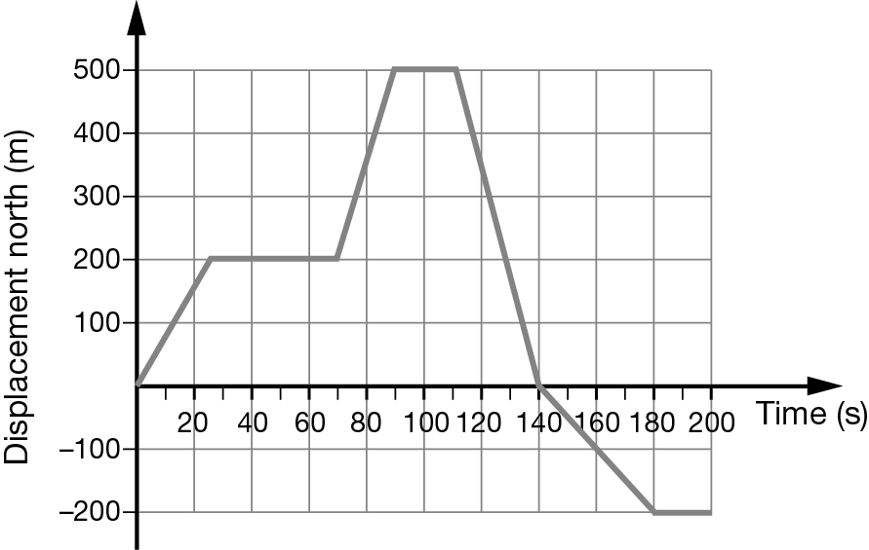

1. How far did the farmer travel during the first minute? ( 1 mark)

*Reading from the vertical axis, at* t *= 60 s,* x *= 200 m.*

b) ( 2 marks)

Which of the following describes the motion of the farmer at t = 120 s? Explain or show your reasoning

A stationary

B heading forwards with a speed of 17 m s–1

C decelerating

D returning back with a speed of 17 m s–1

*D. The speed is given by the gradient of the graph at this time.*

*= –16.666*

*≈ 17 m s–1 in the opposite direction (i.e. returning back towards the property). (2 marks)*

*(If no calculation, full marks as long you explain the negative gradient indicates travelling in opposite direction)*

c) Determine the total distance travelled by the farmer over the entire period? ( 2 marks)

*The farmer travelled 500 m forwards, then 500 m back to his original position, then 200 m further back: a total of 1200 m.*

*d= 200+300+500+200=1200m*

d) Determine the average velocity of the farmer during the last 60 s of his journey? ( 2 marks)

*Average velocity =  = vav = = 3.3 m s–1 back towards theproperty*

Question 5

A car reaches a speed of 72 km h–1, from rest, in a time interval of 5.0 s.

a What was the average acceleration of the car in metres per second?

*a 72 km h–1 =  = 20 m s–1 (1 mark)*

** *(1 mark)*

b The car then maintains this speed for 15 s. How far is it from its starting position at the end of the 15 s?

*Let total distance =* s*1 +* s*2 where* s*1 =* ut *+ 0.5*at*2 and* s*2 =* vt *(1 mark)*

s*1 +* s*2= (0 + 0.5 × 4.0 × 52) + (20 × 15) (1 mark)*

*= 50 + 300 (1 mark)*

*= 350 m*

c The car now decelerates uniformly at a rate of 4.0 m s–2, until it comes to a stop. On the axes provided, draw the velocity–time graph for the car’s entire journey.

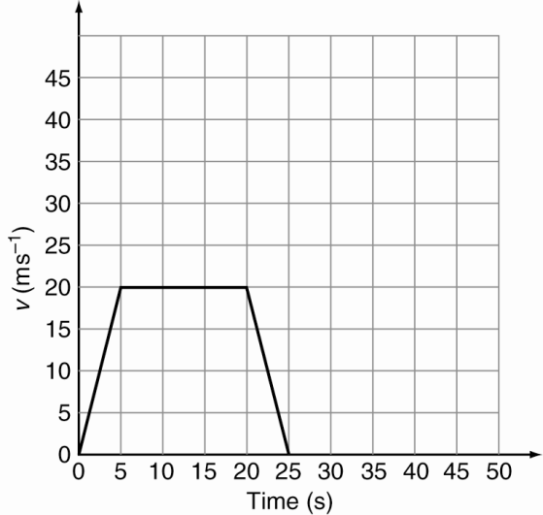

*1 mark per section correctly drawn (3 marks)*

*Answer is consequential: gradient for first 5 s is equal to the answer to part a.*

*Horizontal section from* t *= 5 to* t *= 20 s is a conversion of 72 km h–1 to 20 m s–1.*

**d.** Using the graph determine the total displacement ( 3 marks)**

*=  (2)*

*=50+ 300+50= 400m (1 mark)*

e. Calculate the average velocity of the car during its entire journey.

vav = =  = 16 m s–1 (1 mark)

Question 6

A car travels 1.00 km east, 2.00 km south, 3.00 km west and 4.00 km north.

1. Draw a vector diagram including the resultant, drawing the relative lengths correctly ( 2 marks)

1.0

3.0

4.0

2.0

2.0

2.0

Resultant

1 mark correct vectors, 1 mark resultant

1. Determine the resultant displacement of the car. (3 marks)

* (1)*

*Direction  (1)*

*s= 2.83m S45°E (1)*

Question 7 ( 3 marks)

A radio-controlled toy car starts next to a rubbish bin on the school oval. It travels 20 m north and then travels 15 m east.

a Determine the total distance travelled by the car? (1 mark)

*d= 20+15 =35m*

b Determine the car’s displacement from the rubbish bin. (3 marks)

*,  *

Question 8 ( 6 marks)

A cyclist rides 1.50 km east along a straight path at 27.0 km h−1 before she suddenly notices a ‘path closed’ sign ahead, causing her to stop.

a What is the cyclist’s initial speed in m s−1? (1 marks)

**b** If she takes 0.590 s to react to the sign, what distance does she travel before braking? (2 marks)

**c** Once she pulls on her brakes, the cyclist decelerates at 2.50 m s−2. How far does she travel while coming to rest? (2 marks)

**d** What total distance does the cyclist travel from the time she first notices the ‘path closed’ sign to when she comes to a stop? (1 mark)

*a v= (1 mark)*

***b*** *u = 7.50 m s–1, a = 0, t = 0.590 s, s = ? (1 mark)*

*s = ut + at2*

*= 7.50 × 0.590 = 4.43 m (1 mark)*

*c u = 7.50 m s–1, a = –2.50 m s–2, v = 0.00 m s–1, s = ?*

*use v2 = u2 + 2as (1 mark)*

*0 = 7.502 + 2 × –2.50 × s*

* (1 mark)*

*d add distances from parts b and c = 4.43 + 11.3 = 15.7 m (1 mark)*

Question 9 ( 9 marks)

A stone is thrown upwards at 30.0 m s–1 from the top of a cliff and lands in the sea 40.0 m below. Ignore the effects of air resistance.

a Calculate the speed of the stone when it hits the sea below. (3 marks)

b Determine the total time the stone was moving in the air. (3 marks)

c How far above the sea did the stone reach? (3 marks)

*a Taking up as positive:*

*u = 30.0 m s–1*

*s = –40.0 m (1 mark)*

*a = –9.80 m s–2*

*v2 = u2 + 2as (1 mark)*

*= 30.02 + 2 × (–9.80) × (–40.0)*

*= 1684*

*v = 41.0 m s–1 (1 mark)*

*b v = u + at*

*t = *

*=  (2 mark)*

*= 7.24 s (1 mark)*

*c At the top, u = 0.00 m s–1.(2 mark)*

*v2 = u2 + 2as*

*41.02 = 02 + 2 × –9.80 × s*

*s = –85.8 m*

*The stone fell 85.8 m to the sea from the maximum height. (1 mark)*

**Question 10 (7 marks)**

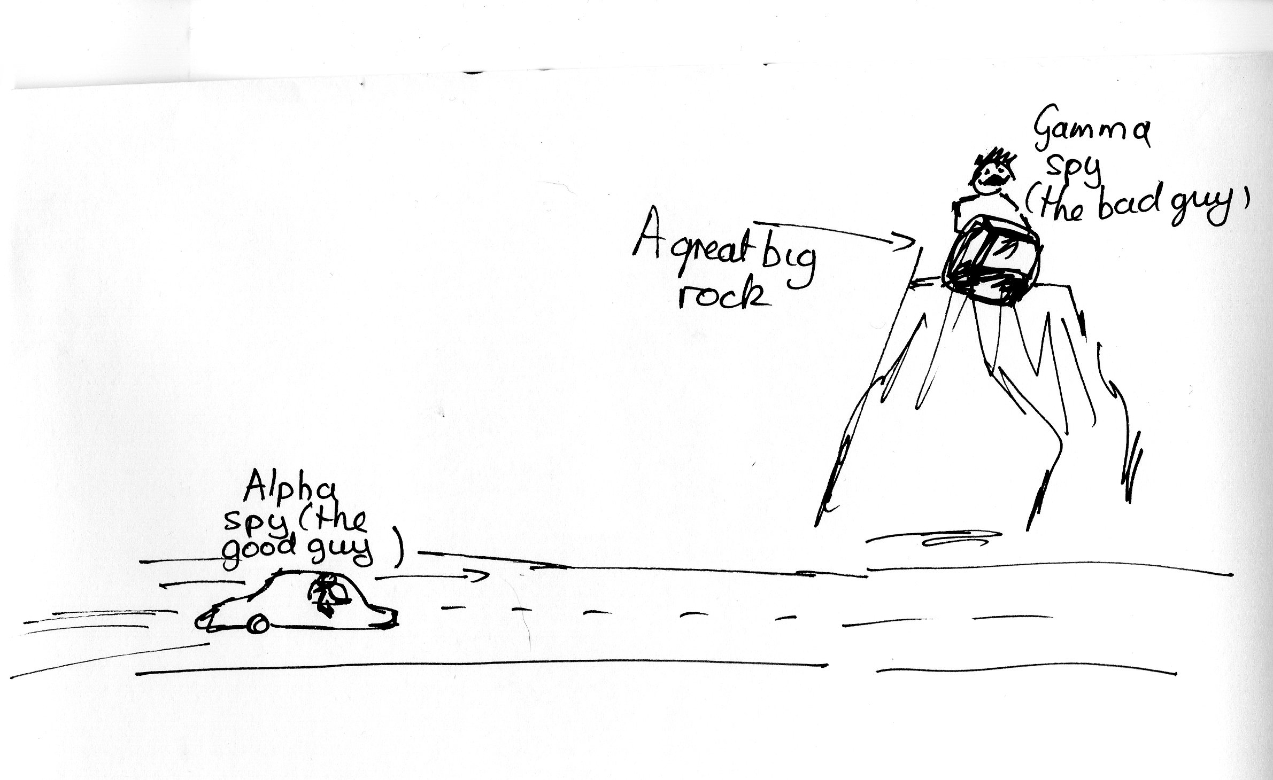

In a cartoon (shown above), the **alpha spy** (the good guy) is trying to get past the **gamma spy** (the bad guy).

The gamma spy is on a ledge 80.0 m directly above a road when he sees the alpha spy in a car travelling towards him at a constant velocity of 12.4 ms-1. The gamma spy drops a large rock off the ledge when the alpha spy is 50.0 m from the point on the road directly below the ledge**.**

**Does the gamma spy drop the rock on the alpha spy?**

Show all working to justify your answer

*Alpha spy is travelling at constant velocity: v=12.4ms-1 , s=50.0m*

*v=s/t therefore t= s/v = 50.0/12.4 = 4.03sec (2 mark)*

*Gamma spy dropping rock: g=-9.8ms-1, u=0 v=? t=? s= -80.0m*

*Either*

*v2 = u2 + 2as (2 mark)*

*= 02 + 2 × (–9.80) × (–80.0)*

*= 1568*

*v = -39.6 m s–1 as going downwards*

*v = u + at*

*t = *

*=  (2 mark)*

*= 4.04 s*

*Alternatively use s=ut + 0.5 at2 and solve for t ( 4 marks)*

*Therefore the rock does drop on the alpha spy (1 mark)*

NOTE: The alpha spy lives to fight another day!